INTRODUCTION

Modern organizations generate massive amounts of operational data that require efficient processing, transformation, and analysis for strategic decision-making. Payroll data is especially valuable because it provides insights into workforce distribution, salary structures, overtime patterns, and departmental expenditures.
The purpose of this project is to build a complete Data Engineering pipeline capable of processing NYC payroll data using industry-standard tools and architectures.
The project implements:

- PostgreSQL Data Warehouse
- ETL Pipeline using Python
- Apache Airflow orchestration
- Dockerized deployment
- Power BI analytical dashboards
- Medallion Architecture (Bronze, Silver, Gold)

This solution enables scalable analytics and efficient reporting for payroll-related insights.

DATASET OVERVIEW

Dataset Name
NYC Citywide Payroll Data

Dataset Source
https://drive.google.com/file/d/1QAigbysPTbqMsIuuQkrLCW6LXZtPJCWA/view?usp=drive_link

Description
The dataset contains payroll information for New York City public-sector employees across different agencies and departments.

Key Columns

Column Name | Description
fiscal_year | Payroll fiscal year
agency_name | Agency/department name
first_name | Employee first name
last_name | Employee last name
title_description | Employee job title
base_salary | Base salary
regular_hours | Regular work hours
regular_gross_paid | Regular gross payment
ot_hours | Overtime hours
total_ot_paid | Total overtime payment
total_other_pay | Other compensation
work_location_borough | Employee work borough
pay_basis | Payment basis

DATA PROFILING AND OBSERVATIONS

Overview

Data profiling and quality assessment were performed on the NYC Payroll dataset before implementing transformation and loading processes into the Silver and Gold layers. The primary objective of profiling was to identify inconsistencies, invalid formats, missing values, duplicate records, and business-rule violations that could affect downstream analytics and reporting.
The profiling process focused on:
- Data completeness
- Data consistency
- Data validity
- Standardization
- Logical integrity
- Numerical validation
- Business rule validation

The analysis was primarily conducted on the Bronze layer, which stores raw ingested data.

General Data Quality Observations

1. Missing and Null Value Analysis

Critical business columns such as:
- fiscal_year
- agency_name
- employee names
- title_description
- base_salary
- pay_basis
- work_location_borough
were checked for empty values.
QUERY:
SELECT *
FROM bronze.nyc_payroll
WHERE fiscal_year = ''
OR title_description = ''
OR agency_name = ''
OR first_name = ''
OR last_name = ''
OR base_salary = ''
OR pay_basis = ''
OR work_location_borough = '';

Observations

Column Name | Missing Value count
Fiscal Year | 0
Agency Name | 0
Last Name | 933
First Name | 936
Middle Initial | 890,008
Agency Start Date | 0
Work Location Borough | 506,214
Title Description | 29
Leave Status as of June 30 | 0
Base Salary | 0
Pay Basis | 0
Regular Hours | 0
Regular Gross Paid | 0
Overtime Hours | 0
Total Overtime Paid | 0
Total Other Pay | 0

- Several non-critical attributes contained missing values.
- Work_location_borough, title_description, first_name, last_name, mid_init showed a noticeable percentage of empty records in the Bronze layer.

Action Taken
Invalid empty strings were first standardized to NULL during silver layer transformation using NULLIF and then standardized again with ‘unknown’ during gold layer transformation.

2. Agency Name Standardization
Agency names were analyzed for:
- Duplicate representations
- Case inconsistencies
- Leading/trailing spaces
- Empty values

QUERY:
SELECT DISTINCT agency_name
FROM bronze.nyc_payroll;

SELECT *
FROM bronze.nyc_payroll
WHERE agency_name = '';

SELECT agency_name
FROM bronze.nyc_payroll
WHERE agency_name != TRIM(agency_name);

SELECT LOWER(agency_name) AS normalized_agency_name, COUNT(*)
FROM bronze.nyc_payroll
GROUP BY LOWER(agency_name)
ORDER BY COUNT(*) DESC;

Observation

- Multiple agency names showed formatting inconsistencies.
- Variations caused by capitalization and whitespace were detected.
- Duplicate agency representations existed in raw data.

Action Taken
Agency names were trimmed and standardized and Case normalizations were applied where necessary.

3. Employee Name Quality Analysis
First and last names were checked for:
- Empty strings
- Case inconsistencies
- Invalid characters
- Single-character names
- Leading/trailing spaces

Observations
- Some employee records contained incomplete naming information.
- A small number of names included invalid formatting patterns.
- Several records contained unnecessary whitespace.

Action Taken
- Whitespace trimming was applied.
- If the first name and last name were both not present, then the row is discarded.
- Casing was standardized.
- Invalid formats were standardized where possible.
- The Jr/Sr were removed from both names to ensure consistency.

6. Agency Start Date Validation
Agency start dates were validated against fiscal years.
QUERY:
SELECT agency_start_date,
fiscal_year
FROM bronze.nyc_payroll
WHERE EXTRACT(YEAR FROM agency_start_date::DATE)
> fiscal_year::INT;

Observations
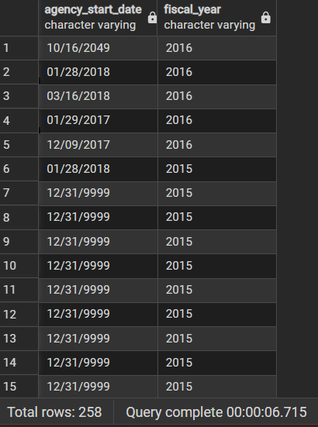
Certain employee start dates exceeded the corresponding fiscal year.

Action Taken
Invalid dates were filtered or corrected during silver layer transformation.

7. Work Location Borough Analysis
Work location borough values were checked for:
- NULL values
- Distinct categories
- Formatting inconsistencies
QUERY:
SELECT DISTINCT work_location_borough
FROM bronze.nyc_payroll;

SELECT work_location_borough
FROM bronze.nyc_payroll
WHERE work_location_borough != TRIM(work_location_borough);
Observations
- Missing borough values were identified.
- Some borough names contained formatting inconsistencies.

Action Taken
Missing borough values were standardized to "Unknown" and Text normalization was applied.

8. Salary Validation Analysis
Salary-related fields were checked for:
- Numeric validation
- Negative value checks
- Currency formatting checks
- Empty value checks

QUERY:

SELECT base_salary
FROM bronze.nyc_payroll
WHERE REPLACE(REPLACE(base_salary,'$',''),',','')
!~ '^[0-9]+(\.[0-9]+)?$';

SELECT regular_gross_paid
FROM bronze.nyc_payroll
WHERE REPLACE(REPLACE(regular_gross_paid,'$',''),',','')
!~ '^[0-9]+(\.[0-9]+)?$';

SELECT total_ot_paid
FROM bronze.nyc_payroll
WHERE REPLACE(REPLACE(total_ot_paid,'$',''),',','')
!~ '^[0-9]+(\.[0-9]+)?$';

SELECT total_other_pay
FROM bronze.nyc_payroll
WHERE REPLACE(REPLACE(total_other_pay,'$',''),',','')
!~ '^[0-9]+(\.[0-9]+)?$';

Observations
- Certain salary records contained non-numeric symbols or malformed currency formatting.
- Some records contained negative salary values.

Action Taken
- Currency symbols and commas were removed during transformation.
- Invalid salary records were cleaned or excluded.
- Numeric casting was applied for analytical processing.

9. Overtime and Compensation Validation
Overtime-related fields were checked for:
- Negative values
- Non-numeric values
- Logical inconsistencies

Observations
- Some employees showed overtime pay despite zero overtime hours.
- Certain records showed overtime hours without corresponding overtime compensation.
- Negative ot hours and regular hours

Action Taken

Rows with negative values were filtered out..

Duplicate Record Analysis

To identify duplicate records, I used a combination of Employee name, fiscal year, agency, job title, and salary fields to identify a unique entry. Duplicate analysis was conducted using combinations of:

Observations
Duplicate patterns mainly resulted from raw ingestion inconsistencies.

Action Taken
Deduplication logic was implemented in the Silver layer using window functions and ranking methods.

System Architecture

Technologies Used
Technology | Purpose
PostgreSQL | Data Warehouse
Python | ETL Processing
Apache Airflow | Workflow Orchestration
Docker | Containerization
Power BI | Dashboard and Analytics
SQL | Data Transformation

Overall Workflow

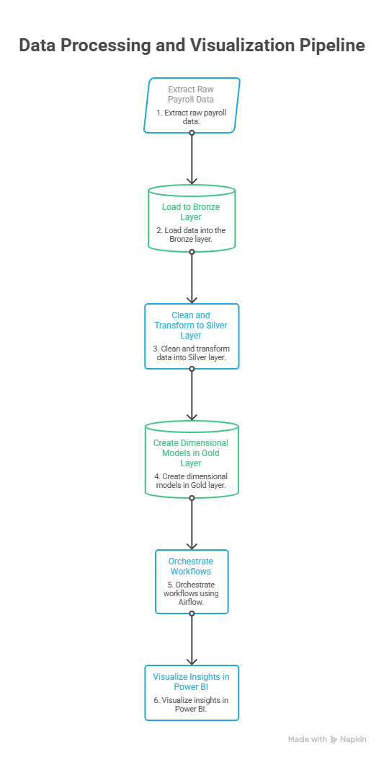
Overall Workflow
Overall System Architecture
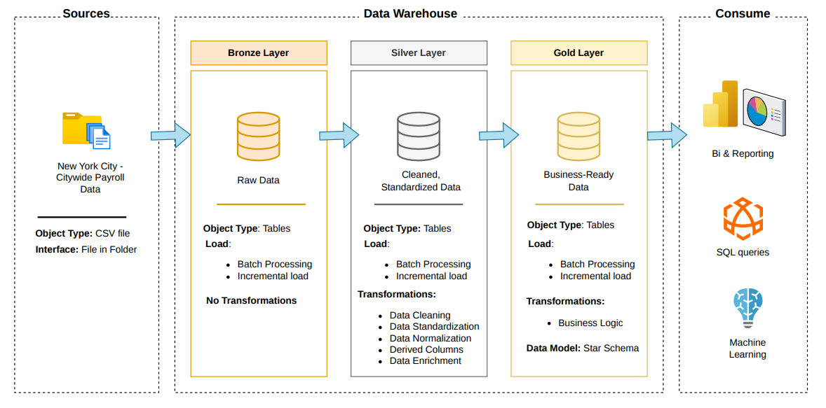
High Level System Architecture

Data Warehouse Design
The project uses Medallion Architecture.
I chose this particular architecture because it gives several practical advantages:
- Data quality control: issues are caught early in Silver instead of breaking dashboards
- Separation of concerns: ingestion, transformation, and analytics are clearly isolated
- Scalability: new data sources can be added without disrupting downstream models
- Reprocessing flexibility: Bronze allows rebuilding Silver/Gold if logic changes
- Better collaboration: engineers work on Bronze/Silver, analysts focus on Gold

Bronze Layer
The Bronze layer acts as the landing zone for the ETL pipeline and stores raw NYC payroll data with minimal transformation. It preserves historical data and tracks batch information for data loading and processing.

Silver Layer
The Silver layer cleans and transforms the raw data by applying standardization, deduplication, and business rules. It produces structured and reliable data for further analysis and supports incremental processing.

Gold Layer
The Gold layer contains business-ready data for reporting and analytics. It uses a Star Schema with fact and dimension tables to support KPI generation, dashboards, and decision-making.

Schema Design

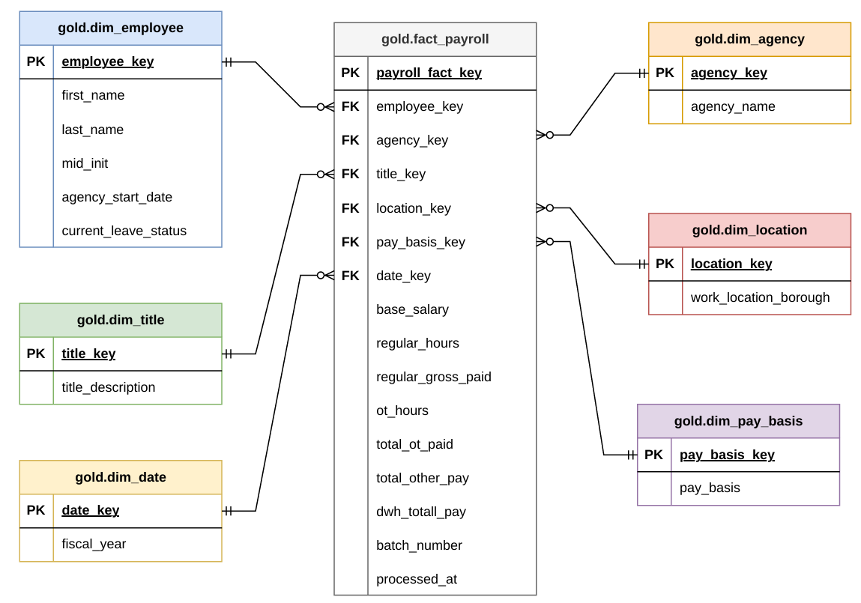
Star Schema Design

The Gold layer follows a Star Schema design to support efficient analytical processing, reporting, and business intelligence operations.
A Star Schema is a dimensional modeling approach in which a central fact table is connected to multiple dimension tables. The structure resembles a star, where the fact table sits at the center and dimensions surround it.
This schema was selected because the primary goal of the project is analytical reporting and KPI generation rather than transactional processing. It also simplifies analytical queries, improves reporting performance, supports power BI visualization and enhances scalability.
Fact Table

fact_payroll
Stores measurable payroll metrics.
Measures include:
- Base salary
- Overtime pay
- Regular gross pay
- Total other pay
- Total Payroll (derived column)

Dimension Tables

dim_employee: Contains employee details.

dim_agency: Contains agency information.

dim_date: Contains time-related attributes.

dim_location: Contains borough/location information.

dim_pay_basis: Contains pay basis categories.

ETL Pipeline Architecture
The ETL pipeline was implemented using Python and SQL, and orchestrated using Apache Airflow.

ETL Stages

Extract
The Extract stage is the initial step taken in the architecture that reads the CSV files and loads the source data into the database.

Transform
In the Transform stage, invalid data is cleaned, duplicates are removed, formats are standardized and business rules are applied to the data.

Load
The load stage loads the processed data into PostgreSQL, updates metadata tables and maintains batch tracking.

DAG Structure

For the project, I developed three tasks for the DAG. It executes tasks sequentially as:

- Bronze Layer Task
- Silver Layer Task
- Gold Layer Task

Airflow Components

Component | Purpose
DAG | Workflow definition
PythonOperator | Executes Python functions
Scheduler | Automates execution
Webserver | Monitoring interface
Workers | Executes tasks

Airflow was specifically selected for this project because of the following reasons:
- Automation
- Scheduling
- Monitoring
- Retry mechanisms
- Dependency management
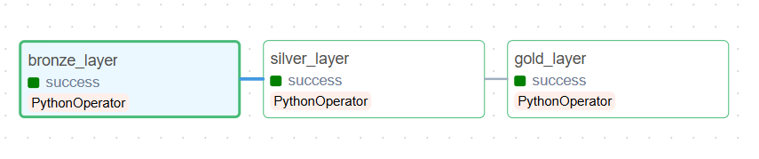

Airflow DAG Gantt chart
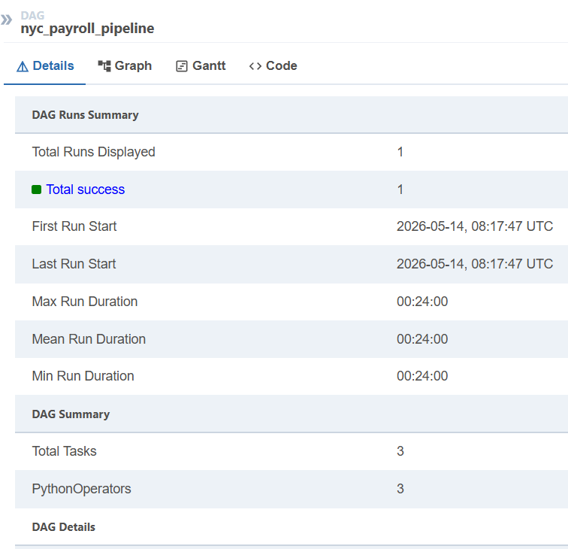

DAG Runs summary

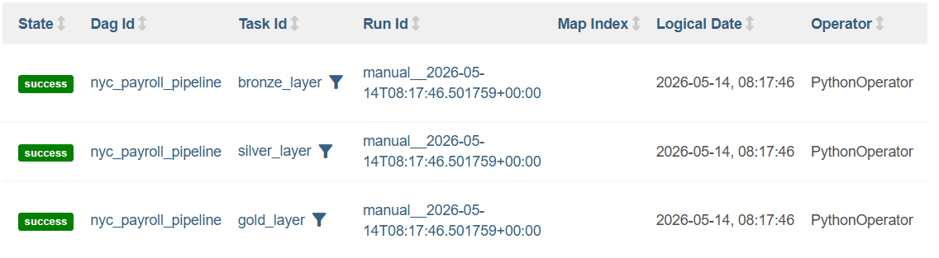
KPIs and Metrics

Core KPIs

Total Payroll Expense
SELECT
ROUND(SUM(dwh_total_pay), 2) AS total_payroll
FROM gold.fact_payroll;
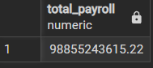

Average Salary
SELECT
ROUND(AVG(base_salary), 2) AS average_employee_salary
FROM gold.fact_payroll;
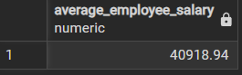

Total Overtime Payment
SELECT
ROUND(SUM(total_ot_paid), 2) AS total_ot_cost
FROM gold.fact_payroll;
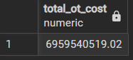

Employee Count
SELECT
COUNT(DISTINCT employee_key) AS workforce_size
FROM gold.fact_payroll;
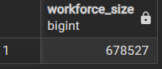

Highest Paid Agency
SELECT d.agency_name, ROUND(SUM(dwh_total_pay), 2) as total_pay
FROM gold.fact_payroll f
JOIN gold.dim_agency d ON d.agency_key = f.agency_key
GROUP BY d.agency_name
ORDER BY total_pay DESC
LIMIT 1;
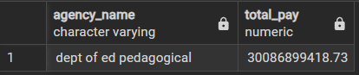

Visual Insights were calculated using Power Bi by connecting the data warehouse to power bi

Trend Analysis
Payroll growth across fiscal years

SELECT d.fiscal_year, ROUND(SUM(dwh_total_pay), 2) AS yearly_payroll
FROM gold.fact_payroll f
JOIN gold.dim_date d ON d.date_key = f.date_key
GROUP BY d.fiscal_year
ORDER BY d.fiscal_year;

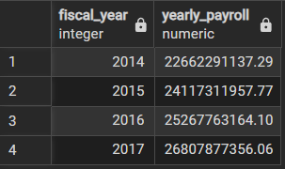
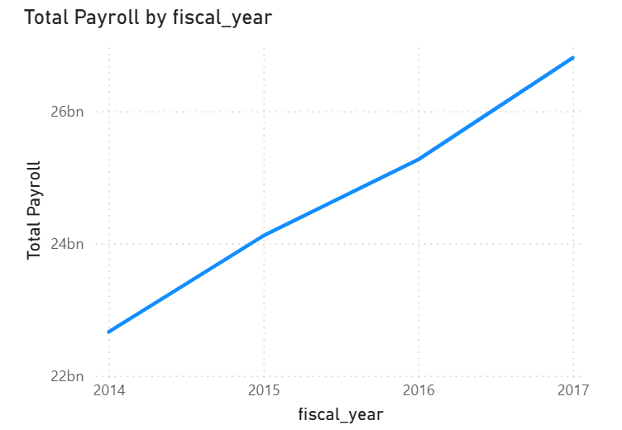
Analysis: Total payroll expenditure shows a gradual increase across fiscal years, indicating rising workforce compensation and operational expenses.

Overtime trend over years
SELECT d.fiscal_year, ROUND(SUM(f.total_ot_paid), 2) AS yearly_ot
FROM gold.fact_payroll f
JOIN gold.dim_date d ON f.date_key = d.date_key
GROUP BY d.fiscal_year
ORDER BY d.fiscal_year;

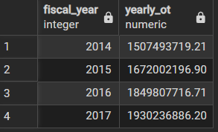

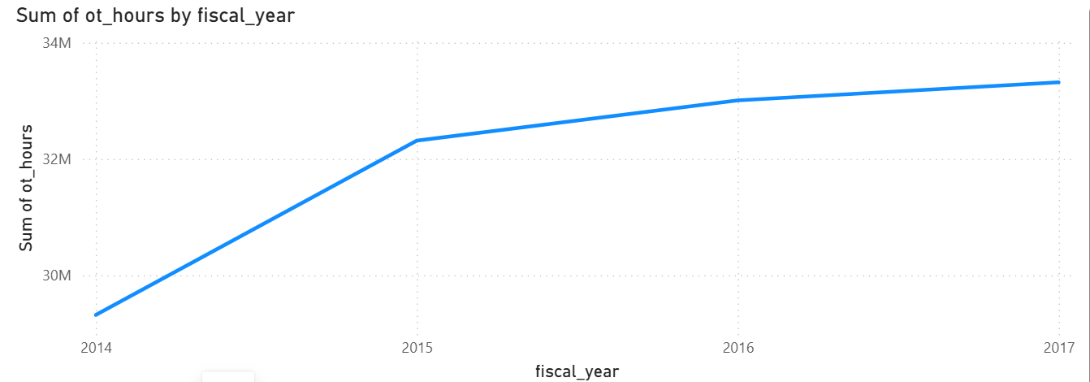

Analysis: Overtime hours increased across fiscal years, indicating rising operational workload.

Workforce size over the years

SELECT d.fiscal_year, COUNT(employee_key) AS workforce_size
FROM gold.fact_payroll f
JOIN gold.dim_date d ON f.date_key = d.date_key
GROUP BY d.fiscal_year
ORDER BY d.fiscal_year;

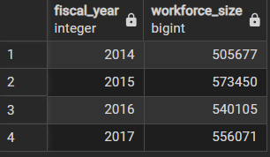

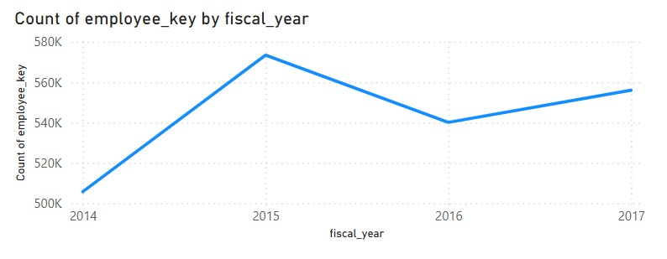
Analysis: The workforce trend analysis shows fluctuations in employee count across fiscal years, with significant growth in 2015 followed by a decline in 2016 and moderate recovery in 2017.

Dimensional Analysis
Dimensional analysis was performed across multiple business dimensions.

Salary by Agency
Highest payroll spending agency
SELECT d.agency_name, ROUND(SUM(f.dwh_total_pay), 2) AS total_payroll
FROM gold.fact_payroll f
JOIN gold.dim_agency d ON f.agency_key = d.agency_key
GROUP BY d.agency_name
ORDER BY total_payroll DESC
LIMIT 10;
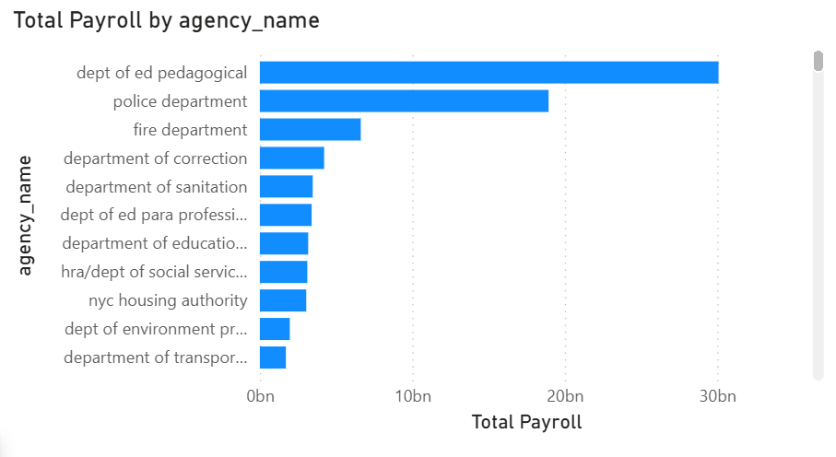
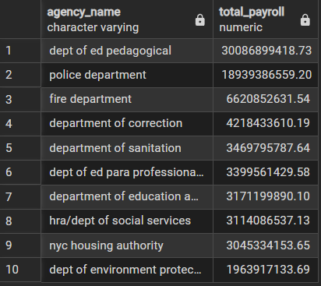

Salary by Borough
SELECT d.work_location_borough, ROUND(SUM(f.dwh_total_pay), 2) AS total_payroll
FROM gold.fact_payroll f
JOIN gold.dim_location d ON f.location_key = d.location_key
GROUP BY d.work_location_borough
ORDER BY total_payroll DESC
LIMIT 10;
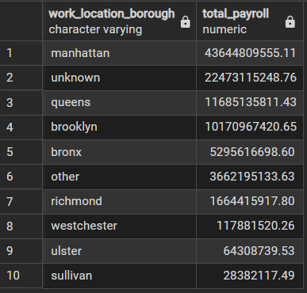
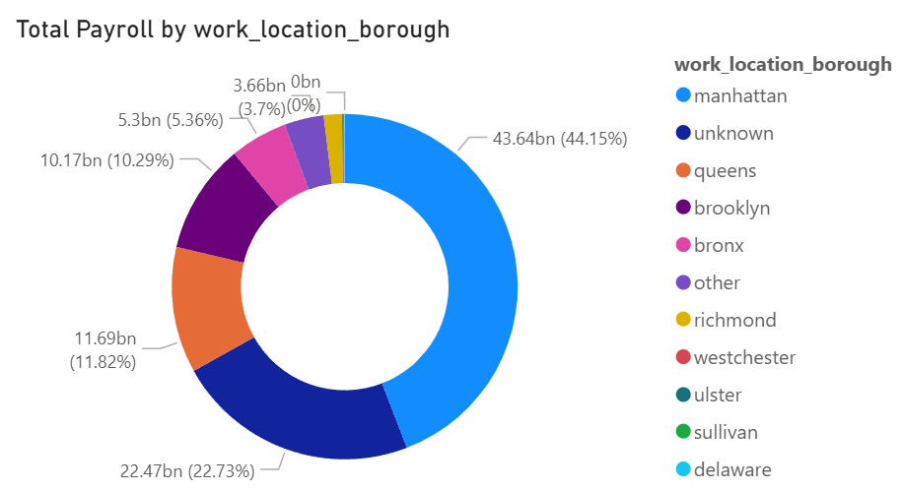

Salary by Pay Basis
SELECT
pb.pay_basis,
ROUND(SUM(fp.base_salary), 2) AS total_salary
FROM gold.fact_payroll fp
JOIN gold.dim_pay_basis pb
ON fp.pay_basis_key = pb.pay_basis_key
GROUP BY pb.pay_basis
ORDER BY total_salary DESC;

